- Surviving The Shadow Muse
Ariane on 27 January 2021
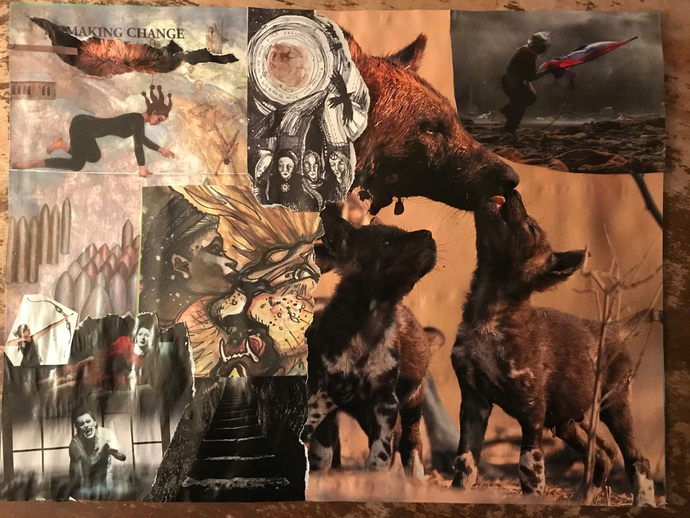

I am returning to the stairwell all these years later to take her outstretched hand
I need my twin
In my darkest hour, I feel defeated
I am holding pain around closing my heart to feeling, separating myself from myself
I am battling an urge to evade myself
I am ashamed of turning 60 and becoming aware I have been an imposter of myself all these years
I am bound or trapped by lingering beliefs that I am done for, that my fate is sealed
My primary emotion is a thawing numbness
My message is "do not override the pain but sing it open"
My name is AMRA, Anger Monster Rage Avenger

