- Honor Killing
Ariane on 1 February 2021
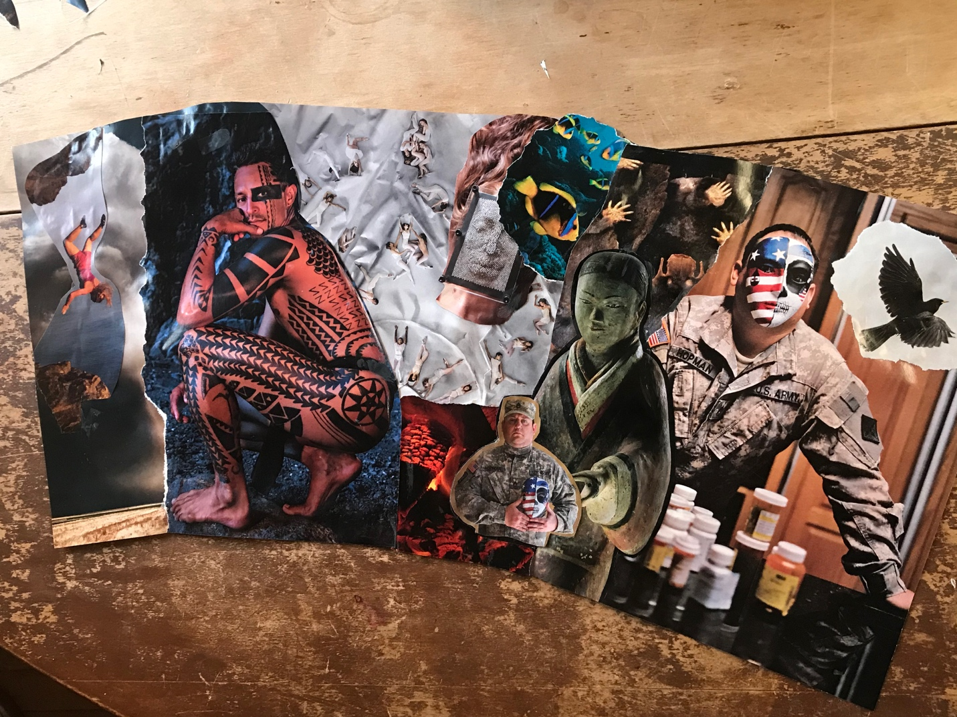

I am tired of the masquerade of war parading as honor killings, dutybound flag raising horrors, protective justifications to serve bottom line imperatives
I am sorry for what passes for manhood these days
For what does it really mean to be a man?
Remind me for I have forgotten
It has been so long...
I am tired of worn-out lies, threadbare truths caught in vainglorious soul crushing tales, mothers and babies hanging on social margins, dangling in the fray of hungers and poverty, while fatherman mansplains beaming lusty greed at the center of the wheel.
Where did men go so far astray from their hearts, from their own beauty?
I wonder about the inner masculine that gives me agency in the outer world, about what makes a warrior and what makes a soldier following orders, fighting for hierarchies in a "dog eat dog world”, reeling from the latest manufactured trauma inflicted in perennial warring cycles.
Am I "othering" now, I wonder?
I wonder how love and fear coexist within and without me
Once or twice, there were stories of lovers who did not know how to play the part in anything but fleshy deed, and fled in the terror of their own vulnerability
Their hardships softened my calloused and shut down heart, in time
And I would not be who I’ve grown myself to love without them
I feel disheveled at times, hopeful, disgusted, deeply deeply deeply grief-stricken and bereft yet liberated for the wild flocking migration up ahead to territories unknown potential liberations more hospitable to love and light and life itself
I release preferences and false certainties
I forgive myself everything as I set sail for my heart's desires for peace, freedom and fierce love
I trust I’m balancing my being as I breathe with every step I take
I’m returning as my essence self
I want to live a simple life of connection
My message-
Restore what’s been torn asunder,
Re-member who you are
Take your place as a unique droplet within an ocean of awareness...

2.
Surviving the Shadow Muse
Ariane on 27 January 2021
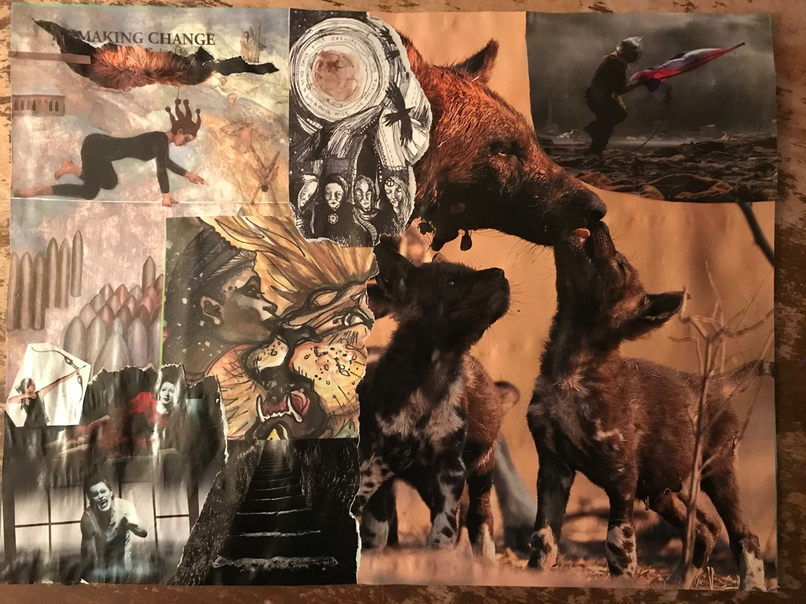

I am returning to the stairwell all these years later to take her outstretched hand
I need my sister
In my darkest hour, I feel defeated
I am holding pain around closing my heart to feeling, separating myself from myself
I am battling an urge to evade myself
I am ashamed of turning 60 and becoming aware I have been an imposter of myself all these years
I am bound or trapped by lingering beliefs that I am done for, that my fate is sealed
My primary emotion is a thawing numbness
My message is "do not override the pain but sing it open"
My name is AMRA, Anger Monster Rage Avenger

